This cover sheet must be attached to all assessment tasks submitted through Canvas or directly provided to your teacher.

Student ID | Student Name | Teacher Name
106066419 | Vishnu Kodmaggi | Ejaz Qadeer

Unit Details
Unit Code(s) | Unit Title(s)
ICTNWK557 | Configure and manage advanced virtual computing environments
ICTNWK559 | Install an enterprise virtual computing environment.

Assessment Task
Task No | Assessment Method and Type | Due Date
2 | Product Based: Plan, Design, Configure and Manage Enterprise Virtual Computing Environment | 28th November 2025

Extension Details (where applicable)
Extension Date for Submission Granted Until

STUDENT DECLARATION
- This is my own work.
- I am aware that penalties exist for breaches of academic misconduct. Refer to the Behaving with Academic Integrity and Penalties for Academic Misconduct pages.
- I have a copy of this assessment
STUDENT SIGNATURE: |  | DATE:
For electronic submissions only:
By typing your name in the student signature field, you are accepting the above declaration.

Course Details
Code | ICT50220 | Title | Diploma of Information Technology (Advanced Networking and Cyber Security

Unit Details
Code(s) | Title(s)
ICTNWK557 | Configure and manage advanced virtual computing environments
ICTNWK559 | Install an enterprise virtual computing environment.

Assessment Task Details
Number | Assessment Method | Title
AT2 | Product Based | Plan, Design, Configure and Manage Enterprise Virtual Computing Environment
Type | Project/Assignment

Assessment Requirements
Purpose of the task:
This assessment is designed to gather evidence of the student’s ability to demonstrate that they have knowledge and skills in planning, designing, configuring, managing, securing and testing virtual infrastructure. To facilitate the process, a scenario of an existing network is provided with information about their policies, requirement and future needs. In the assessment, students will assess the existing organisational systems for their suitability for virtual environment. After assessing the business need, they will research products available to implement and manage virtual infrastructure. Students after the research will propose virtualization host and management software which can assist the company in the consolidation and rationalization of resources.
In the final part of the project, the students will configure and test the functioning of the proposed solution, its integration with the existing network infrastructure in line with the provided business requirement.

Instructions
Students are required to complete this task and submit all evidence required to meet the Product Based evidence marking criteria for this task.
- To complete this task, students can use learning material of the unit and the other resources from online.
- Students need to upload the completed assignment online via Canvas.

Assessment Conditions
Due Date: 28th November 2025
Time: Students are expected to upload the completed assignment before the end of 28th November 2025

Location and environment: Students will complete this assessment Online via Canvas as a self-directed task.
This task requires a student to complete activities typical of those required by a job role and workplace environment applicable to industry.
This includes access to:
- Simulated work scenario

Authenticity: It must be the individual students own work and written in their own words. When quoting specific references, students must acknowledge the source. Evidence of plagiarism or cheating will result in the assessment being assessed as unsatisfactory and further investigation will occur.

Resources and Equipment Required
Students will need to provide:
- N/A – Assessor will provide the resources for this task.
(students may choose to use their own computer instead of a Swinburne PC)
- Online submission via canvas
The Assessor will provide:
- The cover sheet and assessment task (electronically in Canvas)
- Access to classroom
- Access to computer and the Internet
- Access to applicable legislation, industry codes of practice, regulations as required
- Templates
- A site or prototype, where virtual machine environments may be implemented
- Industry standard virtualisation software.
- Network technical requirements
- a range of suitable software

Task Summary
Students are provided with a scenario of an existing network with information about their policies, requirement and future needs. Based on the given scenario students will perform the tasks in 3 parts. Part 1 is related with the analysis and design, part 2 related with Documentation and part 3 is related with the implementation and testing
Part A: Plan, Analyse and Design
- Analyse the existing systems
- Access the systems for their suitability for virtualization
- Identify and Compare industry standards virtualization host software
- Determine virtualization host software requirement
- Obtain technical specification, licensing and system requirements including storage requirement from the Virtualization software vendor
- Obtain Virtualization host platform
- Administrative services
Part B: Documentation
- Required installation process
- Document Recommendation and Submit to required personnel
- Administrative Strategies
- Final Report

Part C: Implementation and Testing
- Install Virtualization host platform
- Install Management Software
- Integration with the existing systems and networks
- Multiple networks for different traffics such as Management, VMs and Storage
- Virtual Switch, security policies, Nic Teaming
- Distributed Switch, VMkernal Ports, Storage traffic
- Create and configure local Datastore
- Create and configure storage connections
- Addition of Software iSCSI adaptor.
- Create and configure Shared Data Store (NFS, iSCSI)
- Create and manage templates
- Configure user roles and administer virtual environment
- Setup and secure user privileges and permissions

Assessment Outcome
To successfully complete this activity, students are required to complete all requirements and submit all evidence to meet the Product Quality Criteria evidence criteria for this task to achieve a Satisfactory (S) result. The outcome of this assessment will contribute to the evidence used in the final decision to achieve competency for this unit/s.
Assessment Submission
To meet the requirements of this assessment you are required to submit the following documents/evidence online via Canvas.
- Completed assessment task cover sheet
- This assessment document with the assessment task cover sheet and completed responses to all questions

Student Name | Vishnu Kodmaggi | Student ID | 106066419

STUDENTS – Your tasks START here.

Brief Overview of the Business
EjazNet Corporation’s is a small fast-growing company with Multiple Offices, which provide services to the private companies and very frequently to Australian government departments as well. A small IT team is in place and have established networks in operation, which at this stage is running on premises and have the following network topology.
Head Office

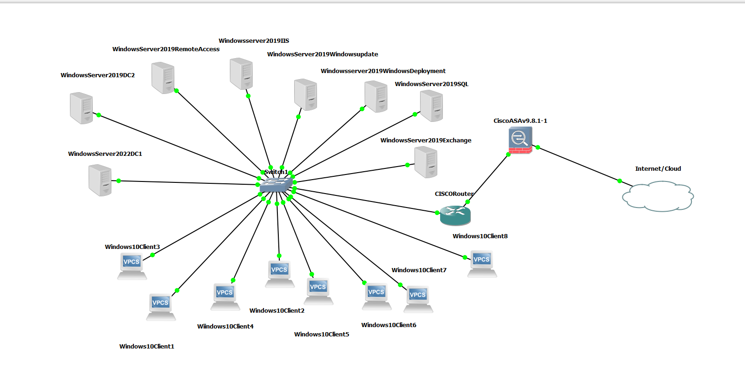
Branch Office
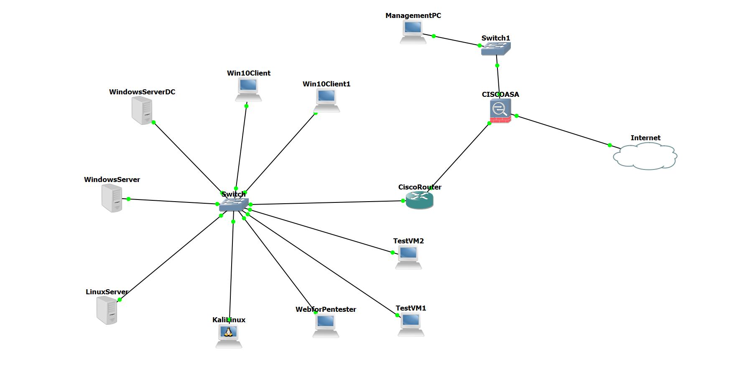
To reduce the operating cost of the business, the management is looking for a rationalization in the company processes. The cost related with the IT services is a significant part of the operating cost and in the management view because of the growth in the business they may also need to further invest in the growth of IT services which could be a strain to the Budget.
An IT consultant hired by the company pointed out that the current Infrastructure and its operation is inefficient and involve high cost in maintenance and routine functioning, including the cost of utilities, floor space, down time cost because of hardware failures and procurement of equipment and parts etc. The consultant also pointed out that the current network does not support any flexibility to the work force which also have a mobile sales team.
He further out that any future expansion under the current arrangement will also be more expansive including relocation to bigger new premises which may cost a lot in the current environment. The consultant recommended the investigation and implementation of technologies such as Virtualization and Cloud for the current set up and for any future expansion.
In view of the recommendation, management wants its own IT Team to explore the virtualization technology to rationalise the current setup. The management first want to start the process at the Branch Office without impacting the Head Office where critical servers are in place. They want you to provide a flexible solution in terms of infrastructure and work conditions for current and future needs.
Since the project is important in management vision, so they created an outline for the work involve. The outline has 3 components.
1 – Doing research in the proposed technological solution, in doing so they want all the work which is conducted must adhere with the company guideline, policies, procedures, structure and technical requirement which will be outlined in the sections below:
2- Document and report the research findings, process and implementation guidelines
3- Prototyping and testing using the technical solution proposed by you making sure that the requirements are meet.
Company guideline for the project
Since virtualization crosses many technical and departmental boundaries. So, before you commit to a particular vendor solution, it is essential that you do:
- A thorough evaluation in as close to a production environment as possible
- Implements proof-of-concept projects
- Pilots to determine if the vendor solution will meet the company business requirement
- Testing must be done around the technical outcomes outlined under the Company Technical requirements
Company General Requirements
- Reliability: Lesser downtime and disaster recovery etc.
- Ease of Implementation and Management and for that purpose you will also explore the management tools
- Any solution must integrate with the existing operational network
- Performance: All the virtual machines perform well under moderate resource allocations in terms of Memory, CPU, Storage and Network. When Virtual Servers and Virtual Desktops all loaded on the Test server the CPU computational capabilities should not bottleneck
- Overall Virtualization host should provide a business grade performance

Company Technical Requirements
- Naming on all systems, switches, port groups, datastores, storages etc need to be customized with the personalization elements such as including your initials in the naming.
- You will use the existing domain controller for the Active Directory and related services such as DHCP, DNS
- Needs to use multiple networks to separate the traffic to prevent any bottle neck. Proposed networks are Management Network, VM network and Storage Network
- All the virtual infrastructure needs to be integrated with the existing networks, and the existing domain controller should authenticate the users for Virtual infrastructure user.
- All the management of Virtual Infrastructure needs to be done through Management Software such as vCenter (VMware) or System Centre (Microsoft)
- For Management Software appliance
  - Needs to be on Management Network (192.168.116.0/24)
- For testVMs need to follow:
  - Needs to be on vSwitch0 – Management Network (192.168.116.0/24)
  - Needs be on a specific VMport group called TestVMs(followed by your initial)
  - Need to be on unused VLAN (must not communicate out with other Networks)

- For Linux Machines need to Follow:
  - Needs to be on local vSwitch1
  - Needs to be on their own VMPort group called LinuxVMs(followed by your initials)
  - Needs to be on their own Network – VM network (192.168.117.0/24)
  - Nees to take address dynamically through DHCP Service
  - Needs to be able to communicate with the Windows Machines and the rest of the network such as Windows Domain Controller, Virtualization host etc

- For Windows 10/11 Clients, need to Follow:
  - Needs to be on local vSwitch1
  - Needs to be on their own VMPort group called WinVMs (followed by your initials)
  - Needs to be on the VM network (192.168.117.0/24)
  - Needs to take address dynamically through DHCP Service
  - Needs to be able to communicate with the Linux Machines and the rest of the network such as Windows Domain Controller, Virtualization host etc
  - Needs to have a template which can be used for future deployment – the template name must have your initials
- For VM templates
  - All templates need to be stored in their own folder, and the folder name must have your initials

- For Local Datastore
  - You will add a new local Datastore and make it available in the Virtualization host
  - You will name the datastore as TestDatastore (followed by your initials)

- For Shared datastore
  - You will use a Distributed Switch for communication
  - Shared Storage will be on its own network – Storage Network (192.168.118.0/24)
  - You will use Windows Server to provide the Shared Datastore
  - You will implement, configure and add a NFS datastore with name TestNFS (followed by your initials)
  - You will implement, configure and add an iSCSI storage in the Virtualization host including adding vSwitch Storage Adapter

- Networking requirements
  - All switches (local and distributed) must have 2 uplinks
  - Need to enable NIC teaming and traffic shaping on the local vSwitch1 which is hosting the VMs and also need to apply security policy (Promiscuous mode: Reject, MAC address change: Reject, Forged Transmits: reject)

- User Rights and Permissions
  - Virtual Infrastructure needs to be integrated with the Windows Active Directory
  - Needs to give, the Domain Administrator of Windows Domain administrative rights for Virtual infrastructure
  - Needs to also add a domain group called vSphereAdmin(followed by your names initials) so that the group have administrative rights in the Virtual infrastructure
  - Create and then Add a user with first letter of your name followed by your surname as a member of that group
  - Login as that user through vSphere Web client
  - Test the user has the administrative powers
  - While logged in as that user give a domain user called testuser followed by your initials a role so that the user can run an existing Windows 10 machine only

Part 1 Plan, Analyse and Design the Virtual Environment
1a. analyse the company existing network (Branch Office) and briefly write about what they need to do to accomplish their objectives.

The current BITS network can consist of a basic star topology that uses a single Windows Server domain controller. Hence, all workloads can run on physical servers with direct-attached storage. The environment can lack redundancy, centralised management and scalability. There’s no virtualisation layer, so workloads can’t be rapidly restored or migrated during hardware failure.

1b. Before prototyping and testing, you need to assess the existing network and determine the systems which are suitable for virtualization. Please list them.

Assessing its current environment.
Typical risks to list
- Single point of failure (1 physical server goes down → full outage)
- No fault tolerance
- No live migration
- Limited capacity
- High hardware costs
- Manual provisioning

Include business impact
- Downtime
- Repair costs
- Data loss
- Slow recovery

1c. The consultant Work pointed out the 2 leading vendors i.e. Microsoft and VMware for their virtualization products that can full fill the company present and future requirement. Your job is to research the products from the 2 vendors and fill the table below and recommend the Virtualization platform which will suit the current and future needs of the company.

Complete the table below by doing the research:

Vendors | Microsoft |  | VMWare
 | Virtualization Software | Management Software | Virtualization Software | Management Software
Features that can support company needs | Type-1 hypervisor that is built into Windows Server; supports Windows and Linux guests. Hence, features can include Live Migration, dynamic memory, checkpoints (snapshots), virtual switches and Failover Clustering with Cluster Shared Volumes (CSV) for high availability. Good integration with Active Directory and Windows tools. | Centralised management for multiple Hyper-V hosts: host groups, VM templates, automated provisioning, monitoring and integration with other System Centre products (Operations Manager, Data Protection Manager). Can manage large virtualised data centres. | Bare-metal enterprise hypervisor. With vSphere you can get vMotion (live migration), High Availability (HA), Fault Tolerance, Distributed Resource Scheduler (DRS) and strong performance and scalability. Widely adopted in its enterprise data centres. | Single console to manage ESXi hosts and VMs. It then requires advanced features like vMotion, HA, DRS and lifecycle management. Supports templates, cloning, permissions performance monitoring and patching.
Technical Specifications and System Requirements minimum from Vendors | Hyper-V host: 64-bit CPU with hardware virtualisation and SLAT; virtualisation support that is enabled in BIOS/UEFI; minimum 4 GB RAM (more required for real workloads); Windows Server supported version (e.g., 2019/2022/2025) as host OS. | Runs on supported Windows Server with x64 CPU, several GB of RAM and SQL Server database. Licensing and sizing can depend on the number of hosts/VMs, but typically 8-16 GB+ RAM and multiple cores are recommended in practice. | ESXi 8 can require x86-64 CPU with hardware virtualisation and NX/XD enabled, at least 8 GB RAM with 12 GB+ recommended for production, and ~32 GB+ storage for installation (more for logs and core dumps). | vCenter Server Appliance Tiny deployment (up to ~10 hosts / 100 VMs) needs about Z vCPUs, 14 GB RAM and ~500-600 GB+ storage; larger environments require more CPU/RAM/storage.
System Requirement to meet Organisational Need | For a small-medium organisation: 2x Hyper-V hosts each with multi-core 64-bit CPUs (with VT-x/AMD-V and SLAT), 64-128 GB RAM, redundant SSD/NVMe or shared storage, and multiple NICs for management, VM traffic and storage. Hence, configure Windows Server Failover Cluster with CSV for high availability of critical VMs. | 1 management server/VM running SCVMM with 4-8 vCPUs, 16-32 GB RAM, SQL Server back-end and enough storage to hold templates and library resources. This can then allow central management of all Hyper-V hosts and future growth. | For the same organisation: 2x ESXi hosts each with supported 64-bit CPU, 128 GB RAM (for headroom), boot storage plus shared storage (SAN/NAS/vSAN) for VM datastores, and several NICs for mgmt., vMotion and VM networks. Hosts then joined into a vSphere cluster for HA/DRS. | Deploy 1 vCenter Server Appliance sized for “Tiny” or “Small” (e.g., 2-4 vCPUs, 14-21 GB RAM, 600-700 GB storage) to manage all ESXi hosts, clusters and datastores, with room for future host/VM expansion.
Licensing Requirement | Hyper-V is included as a role in Windows Server; licensing is mainly for Windows Server per-core: minimum 8 cores per CPU and 16 cores per server must be licensed. Yet, Standard Edition can include the rights for a small number of VMs per fully licensed server; Datacenter Edition allows unlimited Windows Server VMs on that host, makes it better for heavily virtualised environments. | System Centre (including SCVMM) is licensed separately using core-based server management licenses (Standard or Datacenter edition) to manage each Windows Server host. Same core-count rules can apply; Datacenter edition is intended for highly virtualised hosts. | VMware now uses per-core subscription licensing for vSphere/vSphere Foundation and Cloud Foundation, with a mandatory minimum of 16 cores licensed per CPU, regardless of actual core count. All physical cores on all ESXi hosts must be licensed. | vCenter Server is include in current vSphere Foundation / Cloud Foundation subscriptions rather than licensed separately. However, the subscription terms (e.g., 1/3/5 years) can apply, and you will still need to separate Operating System licensing (e.g. Windows Server) for the guest VMs.
Any Additional Notes | Often lower upfront cost if the business already uses Windows Server, since Hyper-V is included. Strong integration with Microsoft ecosystem (AD, Windows Admin Center, Azure) and suitable for organisations that are mostly Windows-based and cost-sensitive. | SCVMM plus the wider System Centre suite can give good monitoring, backup and automation, but it adds some complexity and extra licensing cost. Hence, it is a good choice when the organisation wants a “Microsoft only” stack. | Very mature, widely used platform with a large ecosystem of 3rd-party backup, monitoring and DR tools. Yet, it is excellent for environments that need advanced HA/DRS features and it may need to grow larger over time. | New Broadcom subscription/licensing model can be more expensive and less flexible for small organisations; careful cost planning is required. However, vCenter + ESXi provide powerful centralised management and rich enterprise features if the budget can allow it.

1d. Based on the research you did, what Virtualization Host Software and the Management software you would recommend and why

I recommend implementing Microsoft Hyper-V as the virtualisation host platform together with System Centre Virtual Machine Manager (SCVMM) for centralised management. This solution can provide strong high-availability features, excellent integration with the company’s existing Microsoft environment, and significantly lower licensing and operational costs compared to VMware. Hyper-V offers Live Migration, clustering, replication and scalable management tools that can meet both the current operational requirements and the organisation’s future growth needs. Overall, Hyper-V with SCVMM delivers the best balance of performance, functionality, compatibility and cost-effectiveness for the company.

1e. Plan/design a virtual network, analyse computing environment needs. Before you start work, Management wants a design of the virtual environment you’ll be building. Review their requirements and show them your plan by creating a network diagram. In your network diagram, also, show the existence of Storage (local and shared) solution as well

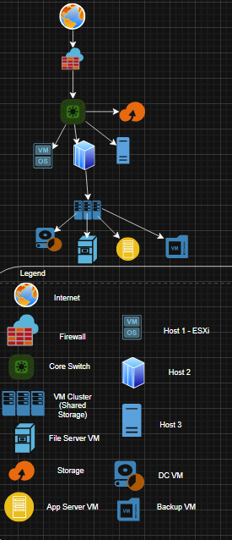
The proposed virtual network design can provide a clustered virtual environment using 3 hypervisor hosts connected to a shared storage solution. Yet, a firewall and core switch can provide secure and efficient routing, while multiple virtual machines can yet deliver key business services such as domain control, file sharing, applications and backups. Hence, the combination of host redundancy, shared storage and centralised management can ensure high availability, scalability and reliability for both current operations and future organisational growth.

Part 2 Plan, Documentation and Approval
In this part you are completing the following and seeking the approval from the Management.
2a Forward your recommendation about the Virtualization Host Software and the Management Software, you are planning to use along with your network diagram to the supervisor.

Dear Ejaz,
Following the review of the organisation’s technical requirements and the available virtulisation solutions, I am recommending the deployment of VMware ESXi as the virtualisation host platform together with VMware vCenter Server for centralised management.
This recommendation best supports the company’s needs for its stability, performance, scalability, and high availability. Hence, it can also align with the implementation work that will be completed in the next stages of this project.

Recommended Virtualisation Platform
Virtualisation Host Software:
VMware ESXi Hypervisor
Management Software:
VMware vCenter Server
Reason for Recommendation
- Enterprise-Grade Stability and Performance: VMware ESXi provides a highly reliable Type-1 hypervisor that is suitable for production workloads.
- Centralised Management: vCenter Server can offer full management of multiple ESXi hosts, VM provisioning, monitoring, clustering, templates, and automation.
- High Availability Features: vMotion, High Availability (HA), Distributed Resource Scheduler (DRS), and storage integration which can allow the business to meet uptime requirements.
- Scalability: Additional ESXi hosts, storage, and VMs can be added easily as the organisation starts to have more further growth.
- Consistency With Implementation: Our practical deployment throughout Part 3 uses VMware ESXi and vCenter, which can ensure compatibility and smooth execution of the project.

Network Diagram
I have attached the proposed network architecture, which includes:
- Internet and firewall layers
- Core switch
- 3 ESXi host servers
- Shared storage system
- Virtual Machine Cluster
- Domain Controller VM, File Server VM, Application Server VM, and Backup Server VM
- Segmented network design with the separately VLANs for management, VMs, and storage.

This design can ensure high availability, security, and performance for the company’s virtual infrastructure.

2b Based on the Technical Requirement of the Business provided above, outline the administrative strategies you will use to give access to users of virtual infrastructure and for the Administration/management of the Virtual Infrastructure.

Strategies for Users Access to Virtual Infrastructure

- Role-Based Access Control (RBAC) via vCenter
- Users receive permissions based on predefined VMware roles (e.g., VM User, Read-Only, Virtual Machine Power User).
- Prevents unnecessary access to ESXi host configuration or storage systems.

- Active Directory Integration
- vCenter Server can integrates with Windows Active Directory.
- Users can authenticate using existing domain credentials.
- AD groups (e.g., VM-Users, VM-Admins) simplify permission management.

- Secure Access to Virtual Machines
- Windows VMs: Access via Remote Desktop Protocol (RDP).
- Linux VMs: Access via Secure Shell (SSH).
- Firewall rules and segmentation restrict VM access to authorised users only.

- Network Segmentation for User Traffic
- User VM traffic is placed on separate VLANs from:
- Management network
- vMotion network
- Storage network
- Prevents any user from accessing vCenter or ESXi host interfaces.

- Logging and Monitoring
- vCenter logs all VM operations (power events, snapshots, console access).
- ESXi host maintain authentication logs and system events.
- Logs are forwarded to a central syslog server if required.

Strategies for Providing the Administrative Access to the Virtual Infrastructure

- Dedicated Administrative Accounts
- Administrators use domain-based privileged accounts (e.g., vSphere-Admin).
- Normal accounts are not used for administrative tasks.

- vCenter Role Delegation
- Granular VMware roles assigned based on required responsibilities, such as:
- vSphere Administrator
- Datastore Administrator
- Network Administrator
- Virtual Machine Administrator
- Supports least-privilege access and separation of duties.

- Dedicated Management Network
- ESXi hosts and vCenter Server are only accessible on a separate Management VLAN.
- The management network is isolated from user networks and production VM networks.

- Multi-Factor Authentication (MFA)
- vCenter Server supports MFA integration through Identity Provider solutions (e.g., ADFS or Duo).
- Adds an extra layer of security for administrator logins.
- Centralised Logging and Monitoring
- vCenter’s built-in monitoring provides health alerts for hosts, VMs, storage, NICs, and switches.
- Logs can then be forwarded to vRealise Log Insight or other SIEMs.

- Least Privilege and Regular Review
- Administrative roles are reviewed routinely.
- Permissions are granted only when it is required and removed after use.
- Meets security and compliance requirements.

2c Based on the Business requirements as outlined in the Technical Requirements, outline the Storage Environment that will be after the implementation of the solution. You may also use a diagram to illustrate that.

Storage Architecture Overview
- Shared Storage Environment (NFS + iSCSI)
All ESXi hosts will connect to centralised shared storage using:
- NFS Datastore (hosted on Windows Server)
- iSCSI Datastore (target on Windows Server or NAS device)
Shared storage will be used for:
- Production VM disks (VMDKs)
- vMotion / HA / DRS operations
- VM templates and ISO images
- Clustering and failover functionality

This can ensure that uninterrupted VM operation even if 1 ESXi host can typically fail.

- Local Storage on ESXi Hosts
Each ESXi host can use local storage for:
- ESXi hypervisor installation
- Local datastore for testing VMs
- Temporary or non-critical workloads
- ISO files and installation media

Local storage is not used for production workloads.

- Backup Storage
A dedicated backup solution will be configured using:
- A Backup VM with large attached disk
- A NAS-based backup repository
Backups will include:
- Daily incremental VM backups
- Weekly full backups
- Replication to secondary storage or cloud (if required)
- Optional snapshots for short-term rollback

This meets business continuity and disaster recovery requirements.

- Storage Network Segmentation
A dedicated Storage VLAN is used exclusively for:
- NFS traffic
- iSCSI traffic
- VMkernel storage interfaces

This ensures:
- High-performance storage access
- Isolation from management and VM networks
- Decreased latency and improved throughput

Part 3 Implement, Configure, Test, and Monitor the Virtual Environment

3a Prepare for installation, obtain virtualisation host platform software

Broadcom the new owner of VMware has outlined the process to obtain the free copy of ESXI host software on their website
https://knowledge.broadcom.com/external/article/399823/vmware-esxi-80-update-3e-now-available-a.html

Note: you need to have a Broadcom account to download that. This is the account we used for doing the Handson Lab as well
Go through the process, login to your account, and then you can access the product through free downloads. On the website, find the download page for VMware ESXi. Take a screenshot of this screen showing its URL and the download link.
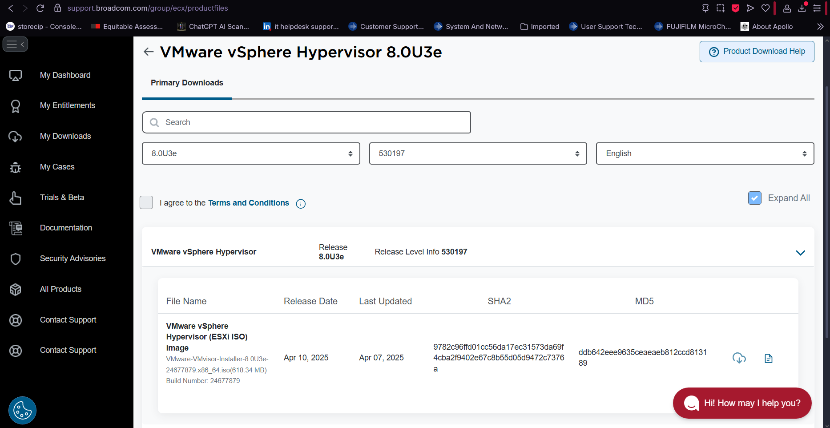
If you are on the correct page you’ll see “VMware vSphere Hypervisor (ESXi)”, the release and release level info.

3b Install Virtualization host platform: Install the Virtualization Host and provide documentation below: Note: you will not be installing the downloaded .iso as it has limitation such as cannot be managed through vCenter etc. You will use the one which you have from the OneDrive folder.

Screens showing that the Virtualization host is installed and have been personalized

3b1 Screen from the VMware Workstation showing the existence of the Instance with name as per requirements outlined above

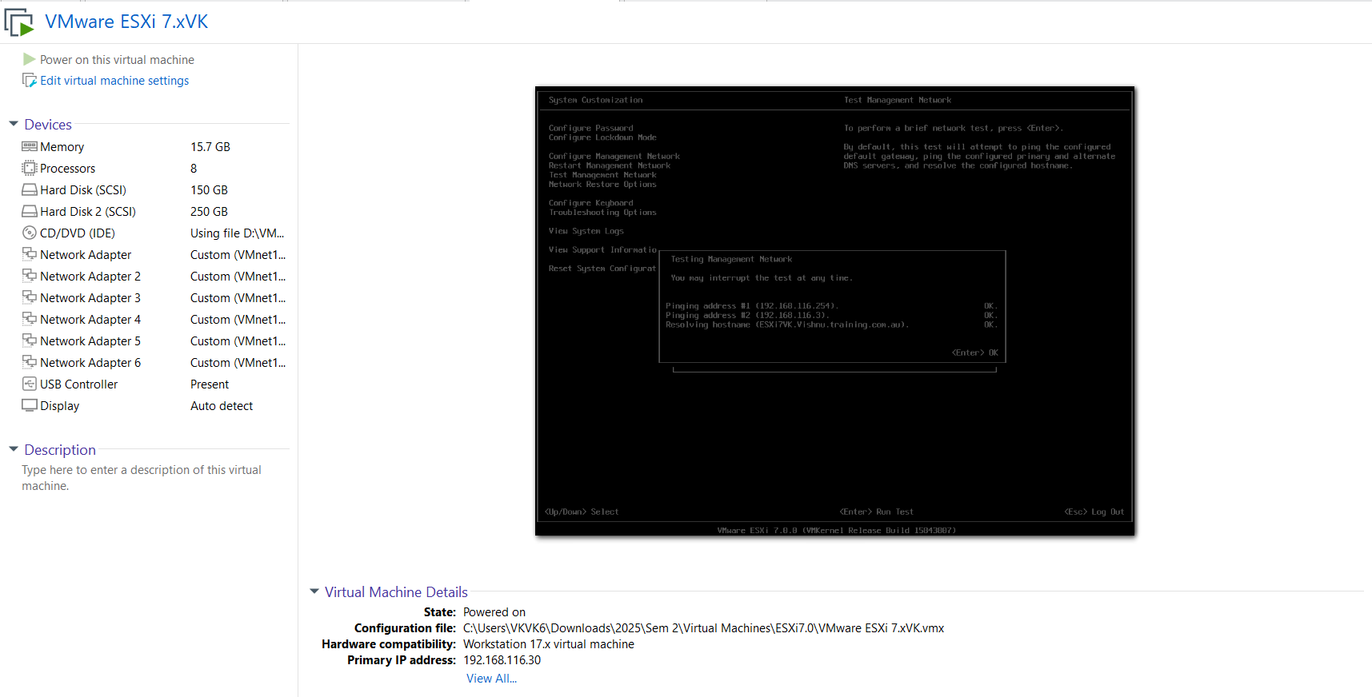

3b2 Screen from the ESXI Host showing the IP addressing Configuration

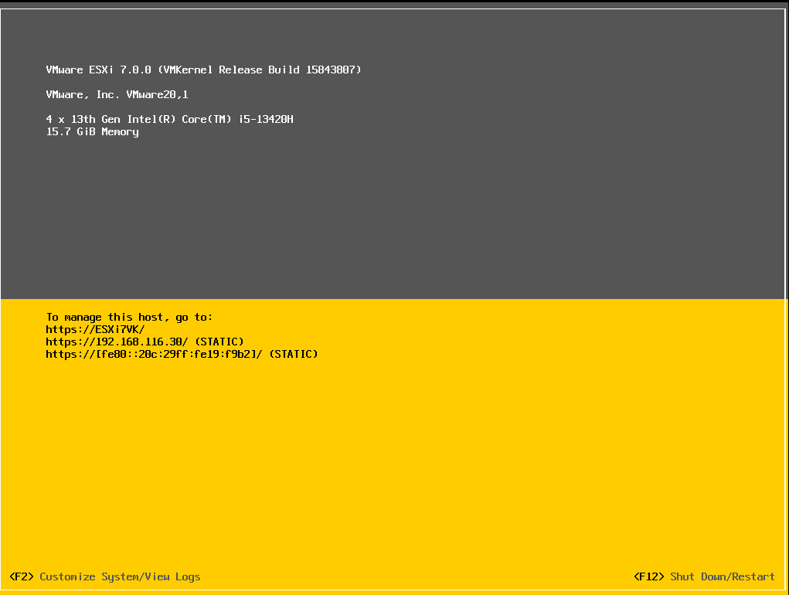

3b3 Screen from Web client showing that you have access to the Host using the fully qualified domain name

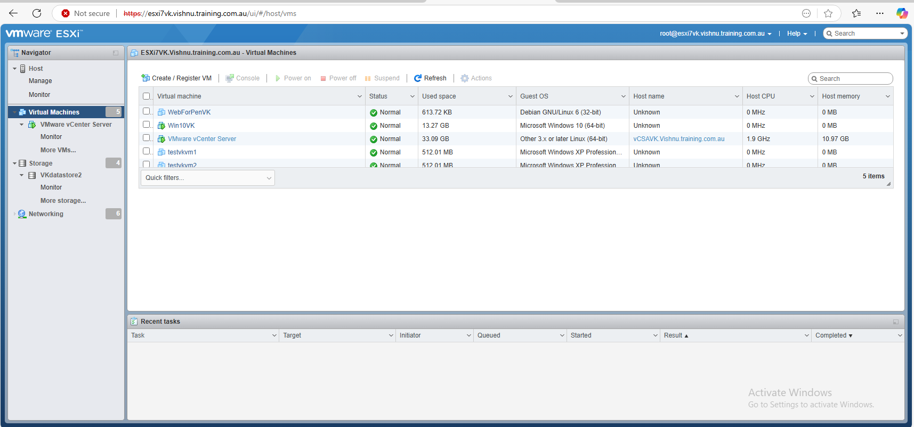

3c Install Virtualization host Management Software and provide documentation below:

3c1 Screen showing the Management Software vCenter Server has been installed

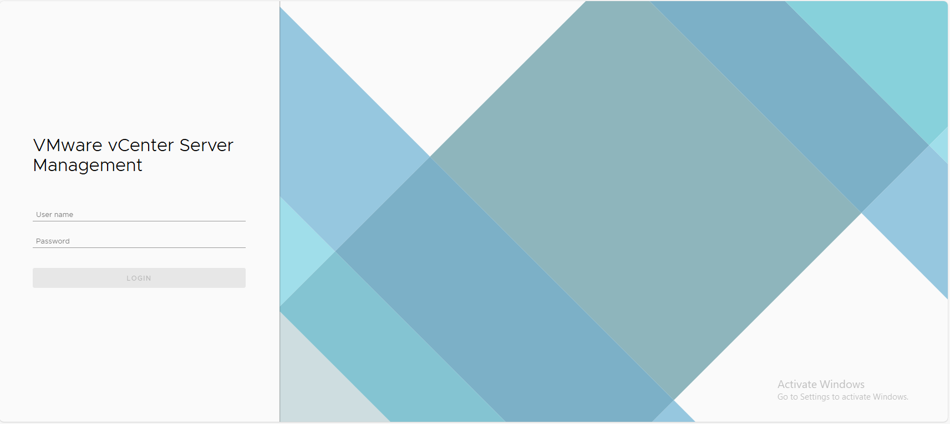

3c2 Screen from the vSphere Web Client showing that you have access to the Management software using the fully qualified domain name

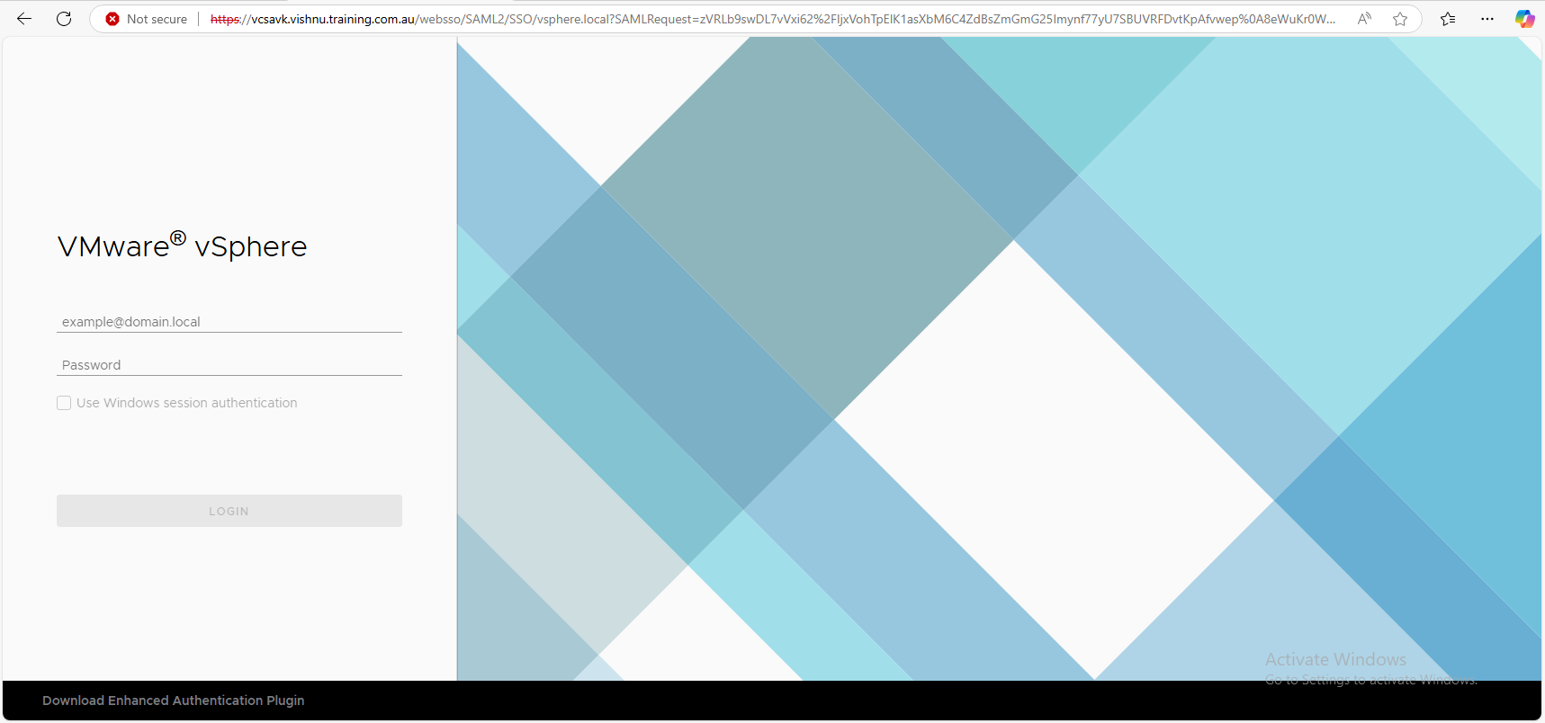

3d Configure Virtual Local Area networks (VLANS) and required security and Virtual Switch (vSwitch) ports.

3d1 Screen showing that vSwitch0 has Vmkernel port and VMport groups as per requirement

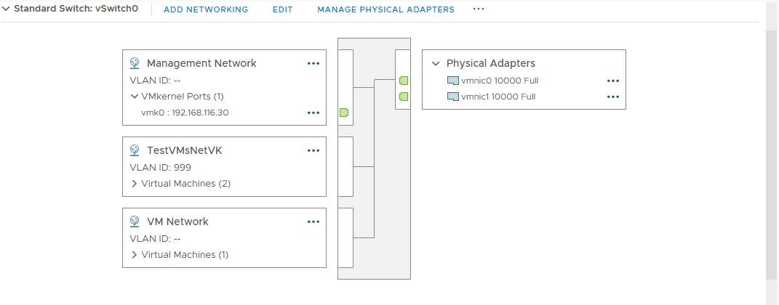

3d2 Screen showing that the testVMs are on their own VMport group and have been assigned an unused VLAN
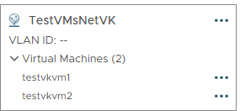
3e Implement required security policies, traffic-shaping and Network Interface Controller (NIC) teaming and configure and manage required multiple networks according to organisational requirement

3e1 Screen showing the existence of vSwitch1

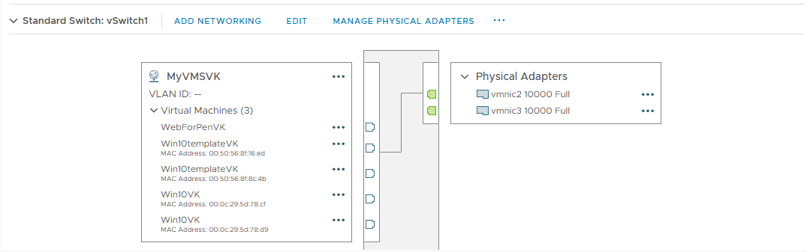

3e2 Screen showing that the Linux machines are on their own VMport group

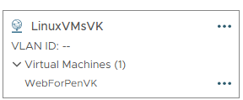

3e3 Screen showing that the Windows Machines are on their own VMport Group

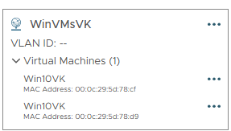

3e4 Screen showing that the Linux machines are on different network (then the Management Network) and got a dynamic address through DHCP

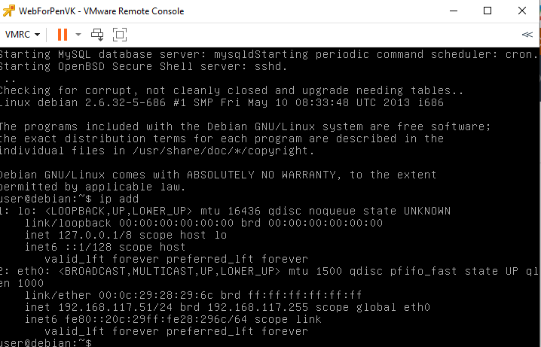

3e5 Screen showing that the Windows machines are on different network (then the Management Network) and got a dynamic address through DHCP

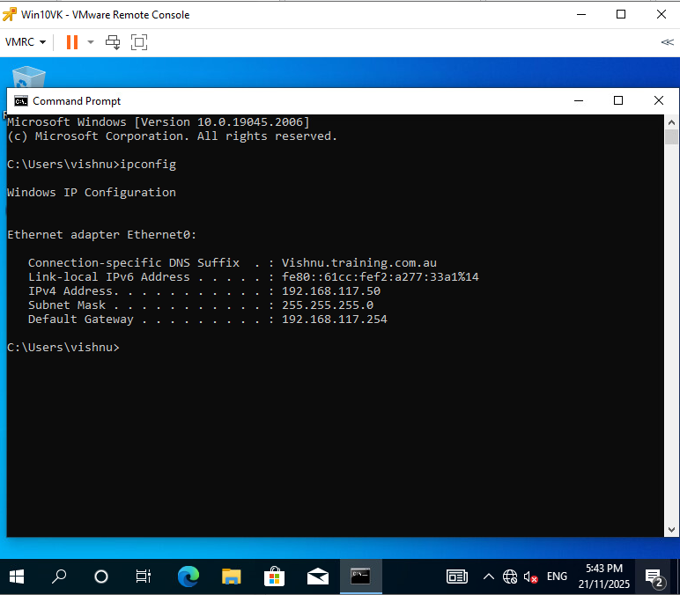

3e6 Screen showing that there is a communication between the Linux VM and Windows VM

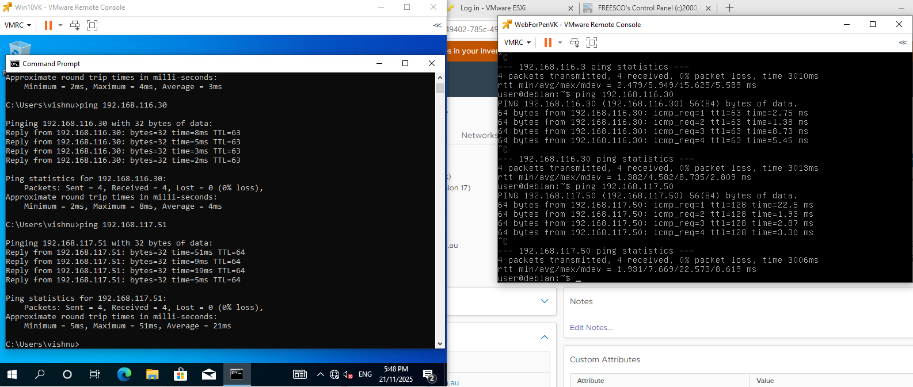

3e7 Screen showing that the Windows Machine can communicate with the systems which are on Management network i.e. ESXI host, vCenter server, Domain Controller etc

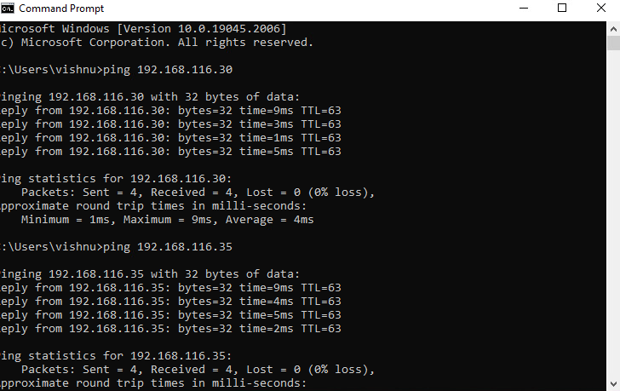
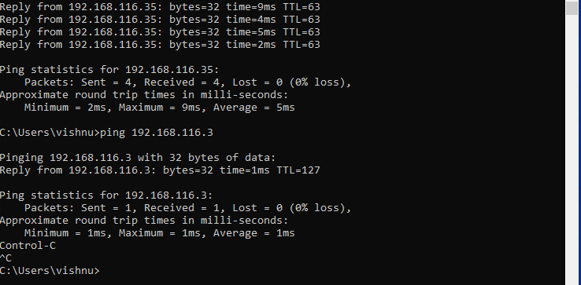

3e8 Screen showing that the vSwitch1 hosting VMs (Linux and Windows) has 2 uplinks

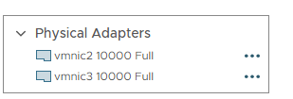

3e9 Screen showing that the Security policies has been applied as per technical requirement of the business

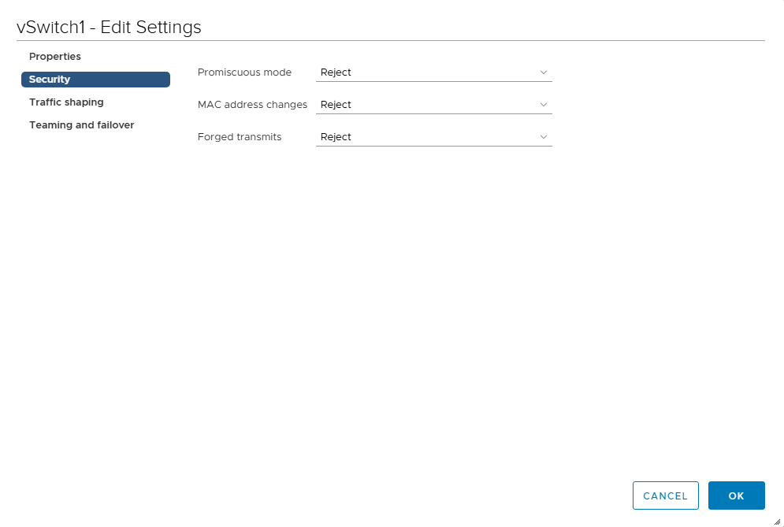

3e10 Screen showing that the Network Interface Controller (NIC) teaming is enabled on vSwitch1 as per technical requirement.
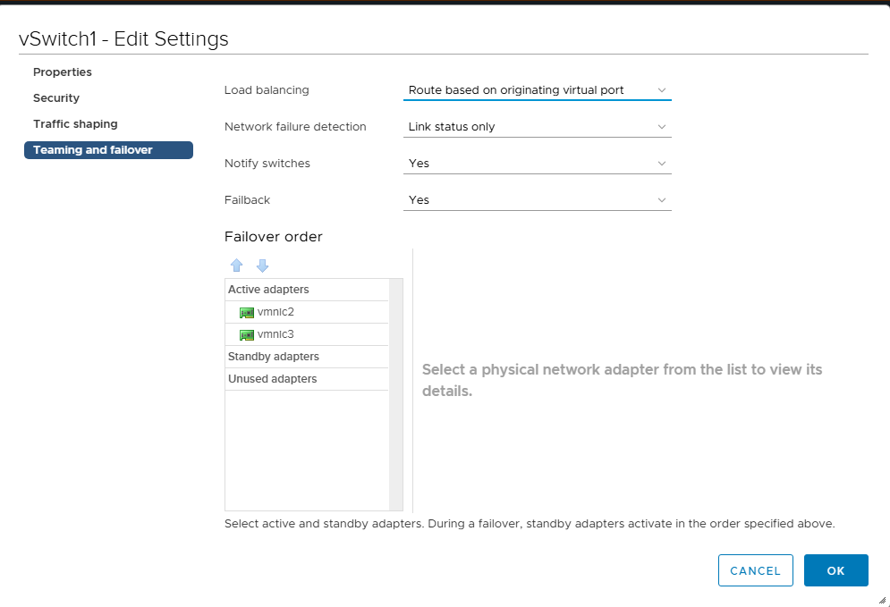
3f Install and test local and shared data store

3f1 Screen from VMWare workstation showing that it has Multiple Local Disks



3f2 Screen showing that a new local datastore has been added as per technical requirement of the business

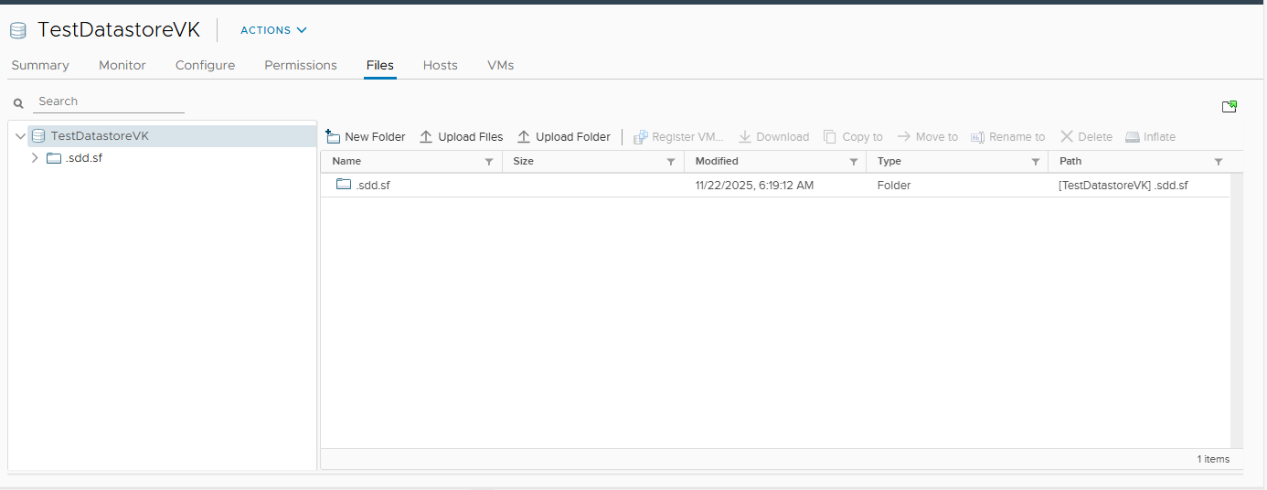

3g Manage required distributed vSwitch Connections

3g1 Screen showing the existence of Distributed Switch under vCenter Server as per technical requirements

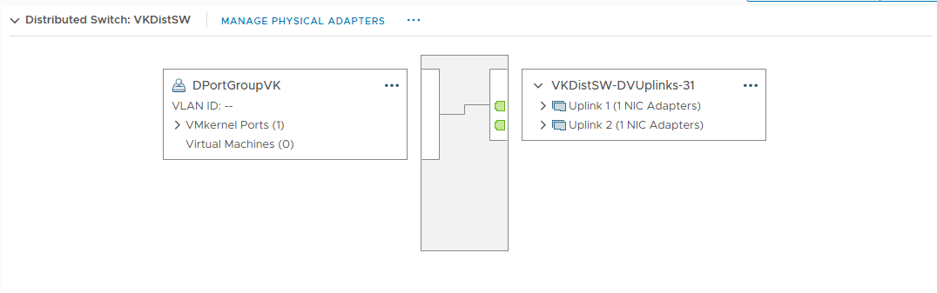

3h Create, Configure, manage and secure virtual storage connections
3h2 Screen showing that the Distributed Switch is on its own network (Storage Network)

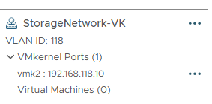

3h3 Screen showing that the Windows Server (Domain Controller) can communicate with the VMKernelPort on the Distributed Switch

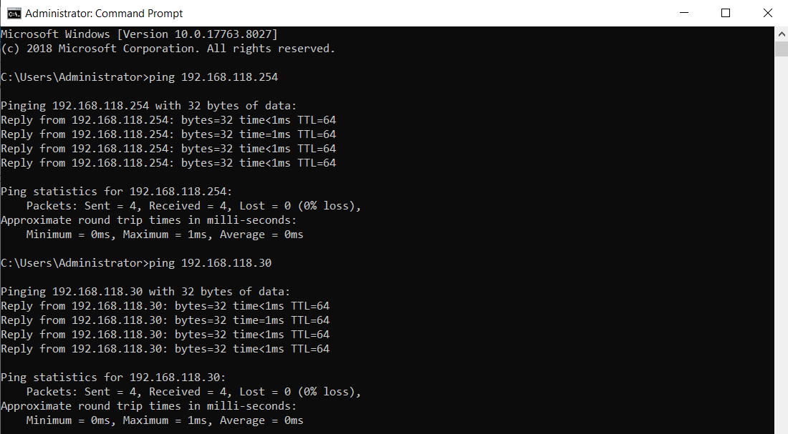

3i Install, configure and test shared datastore
3i1 Screen showing that the Windows Server has Multiple Volumes for NFS and iSCSI storage and are named as per requirements

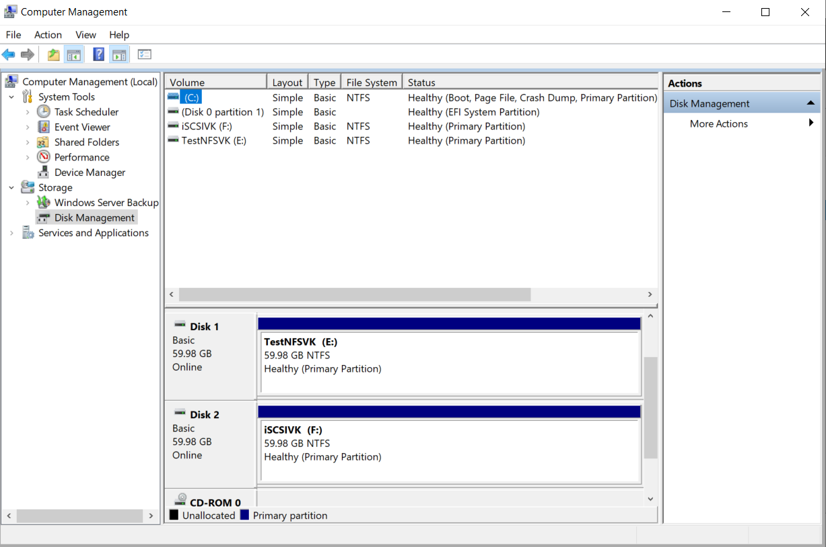

3i2 Screen from Windows Domain Controller, showing the existence of NFS share and the associated security permissions

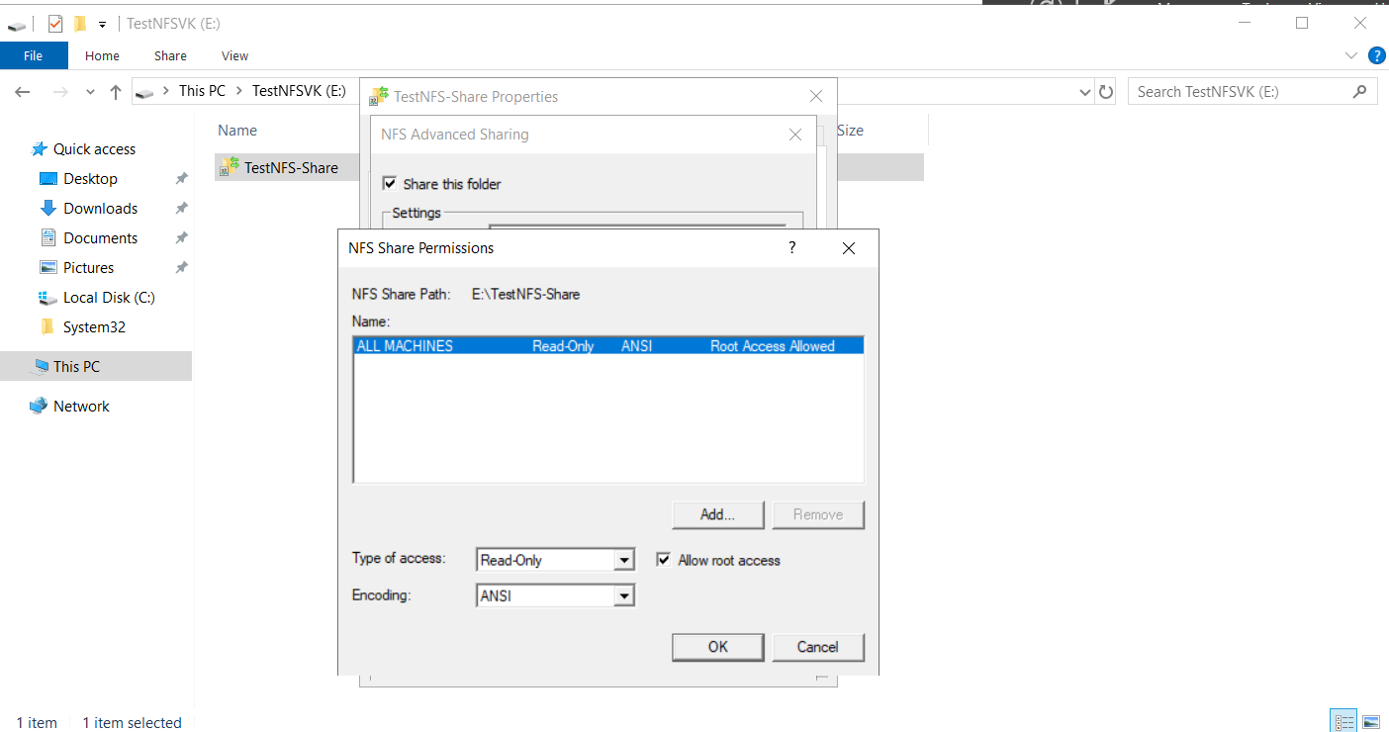
3i3 Screen showing that an NFS datastore has been added and attached with the Virtualization host

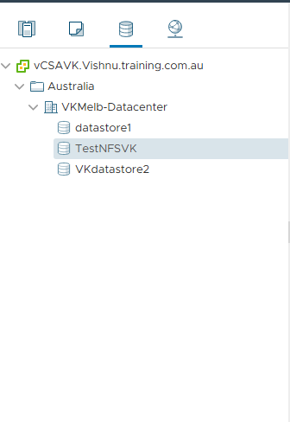
3i4 Screen showing the existence of content in the NFS datastore

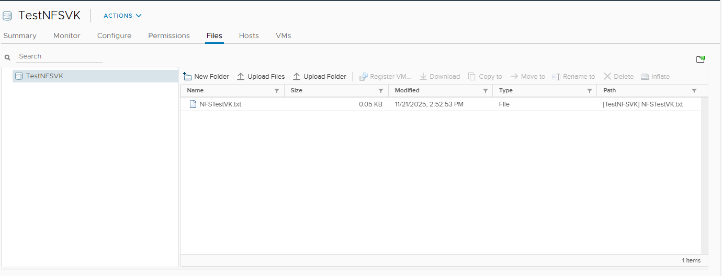
3i5 Screen showing that the Software iSCSI adaptor has been added in the ESXI host

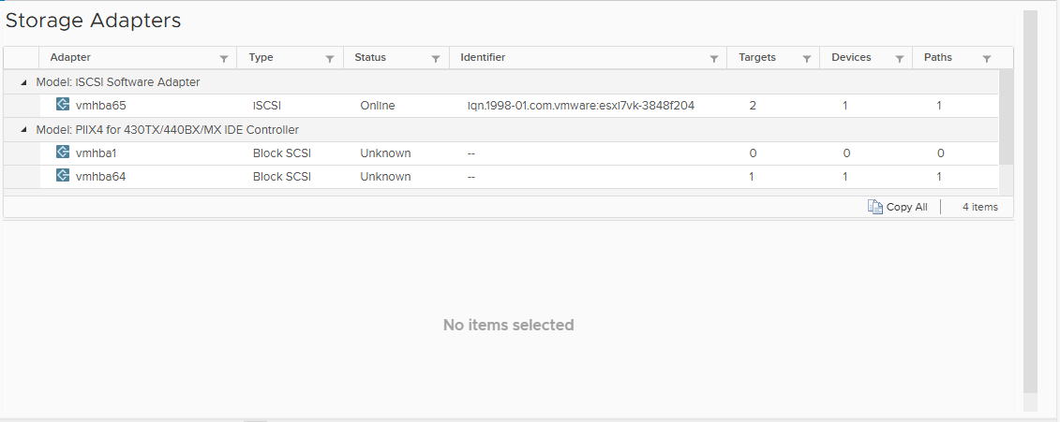
3i6 Screen showing that the iSCSI storage has been added and attached with the Virtualization host

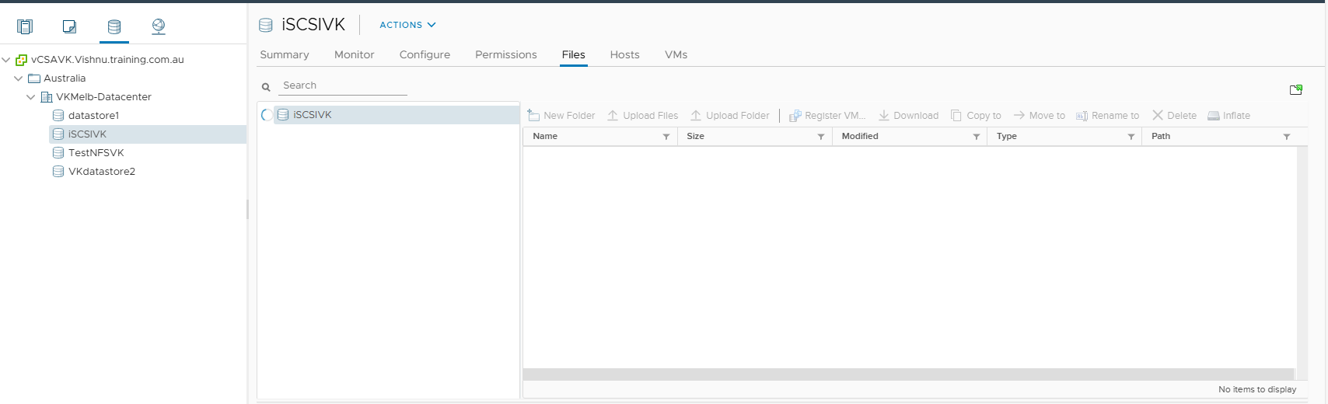

3J Configure templates
3J1 Screen showing the existence of Customized Windows 10 Template in the templates folder

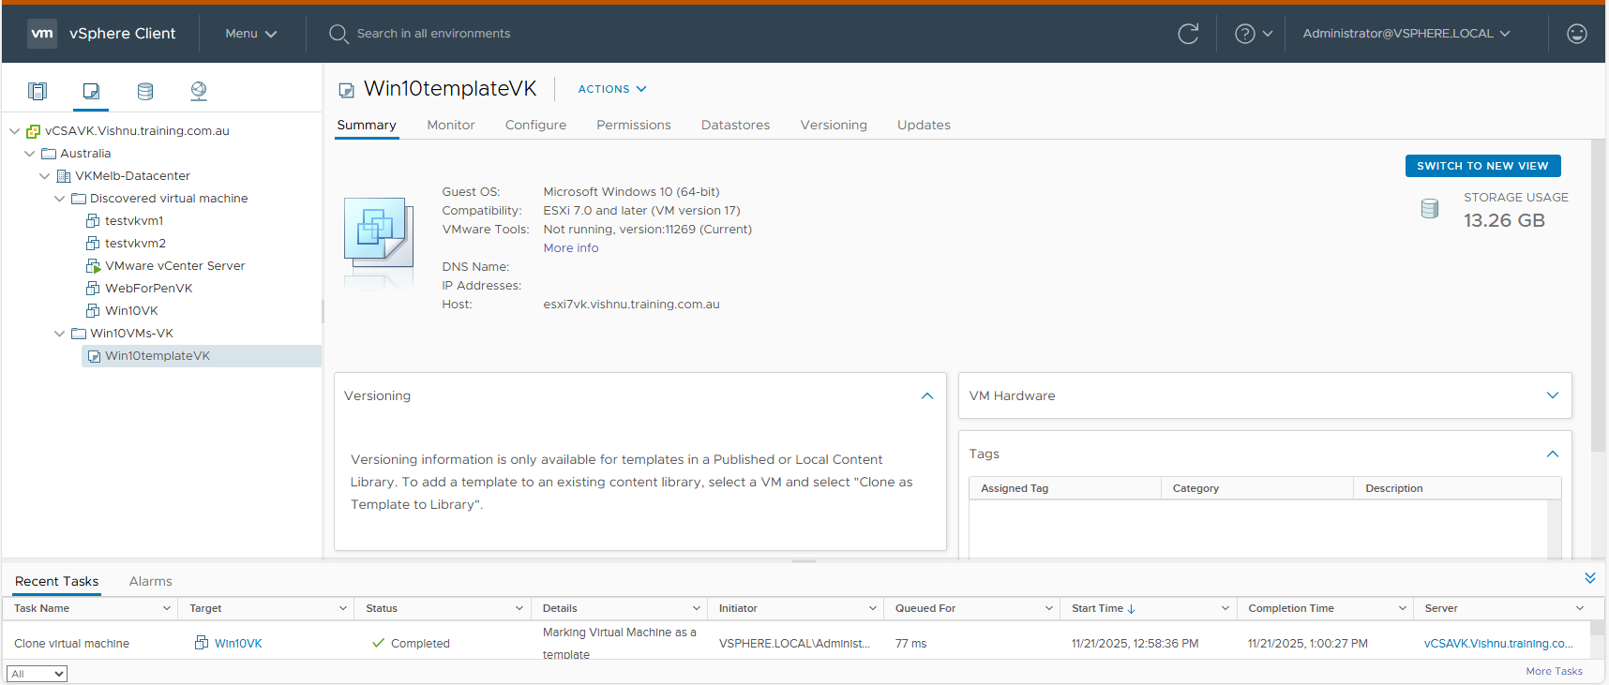

3K Configure required user roles and administer virtual environment
Setup and secure required user privileges and permissions

3K1 Screen showing that the Windows Active Directory has been added as a source of Identity in vCenter

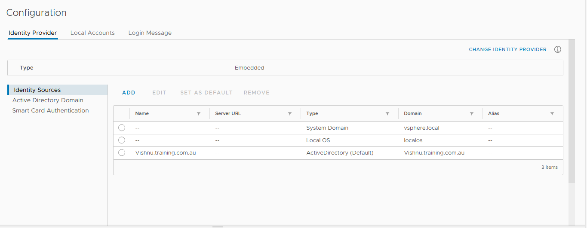

3K2 Screen from Windows Domain Controller showing the existence of user and group as per technical requirements.

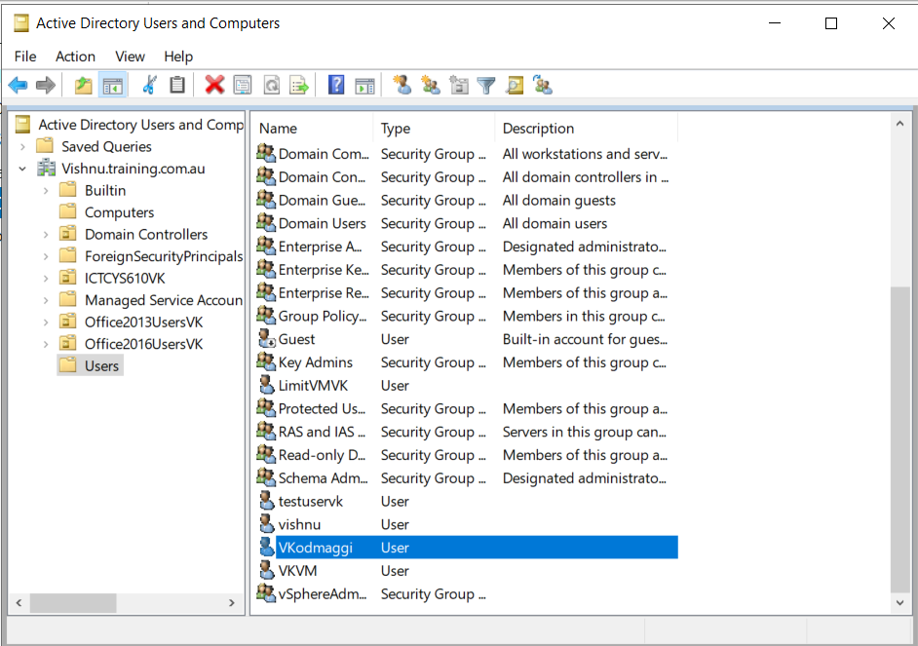

3K3 Screens showing that the Windows Domain Administrator and the Windows group created for managing the Virtual infrastructure have added and assigned the appropriate role in vCenter

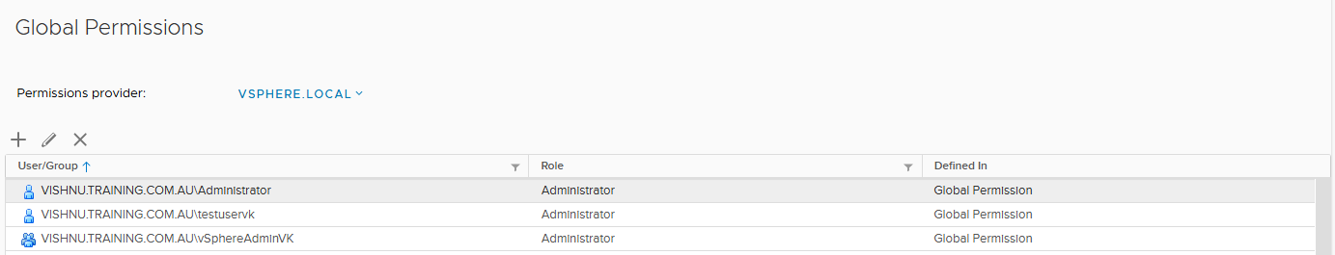

3K4 Screen showing the user who is member of the Group can login to the vCenter Server

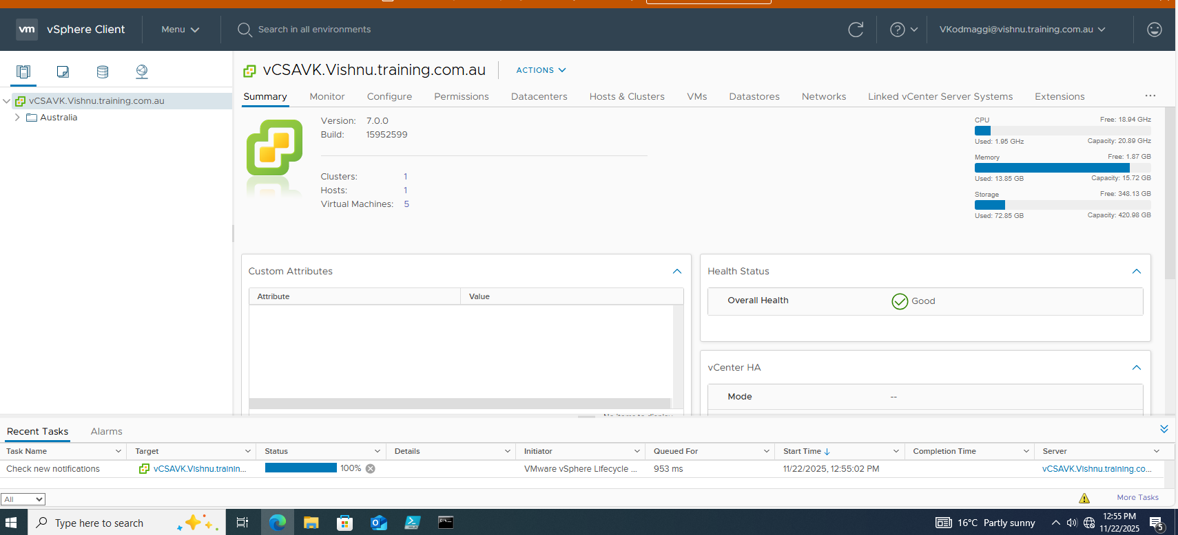

3K5 Screen showing while logged in as the above user (which should have the administrative rights), testuser has assigned a role so that it can run only the Windows 10 machine

3K6 Screen showing that testuser is logged in via vSphere Web Client and can only use the Windows 10 client machine

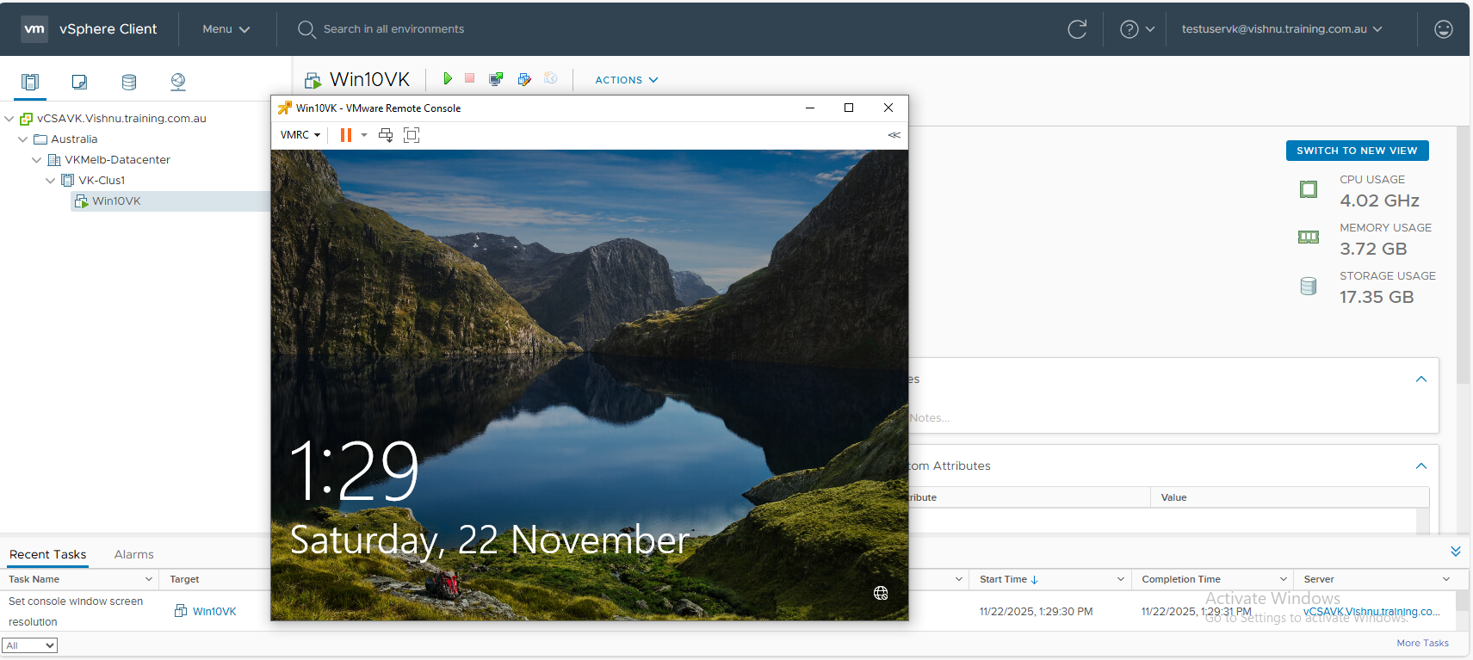

Assessment Task Outcome (Assessor use only)
Assessors: Please return this Feedback and Assessment Task Outcome section to the student. A copy must be retained on the student’s file with the evidence, or feedback will be provided in Canvas and kept in the student’s file with the evidence.
To satisfactorily complete this assessment task the student is required to have provided all correct product evidence. The assessor must provide the student with written feedback specific to their performance. Where the performance outcome is:
- Satisfactory (S) – summarise your findings as this will allow the student to understand why this outcome was achieved.
- Unsatisfactory (US) – provide reasons as to why and you must include information about the areas needing improvement and where further evidence is required.
Where the student is granted the opportunity to resubmit, provide them with a resubmission due date.

Feedback to Student
Assessment Task No |  |  |  |  |  | Assessment Method |  | Product Based
Assessment Task Outcome | ☐ | Satisfactory |  |  | ☐ |  | Unsatisfactory |  | Date
The assessor is to complete the following declaration once the final assessment decision for this task has been made.
Assessor Declaration
I declare that I have provided appropriate feedback and undertaken an assessment process which complies with the principles of assessment and the rules of evidence.
Assessor Name |  |  |  | Assessor Signature |  |  |  |  |  | Date

Other Assessment Information
Academic Integrity | Academic integrity is about presenting academic work in a moral, ethical and honest way. It means using ideas, knowledge and information to develop your own insights, not presenting someone else's work as your own or trying to gain unfair advantage. It also means acknowledging the work of others when you include it in your work.  This includes plagiarism, cheating, buying notes or assignments etc. There are serious penalties that may include repeating a new assessment task or being withdrawn from the unit and/or course. Students must ensure that all assessments are their own work (or group work and clearly noted as such).  Refer to https://www.swinburne.edu.au/student-login/academic-integrity/ for further information.
Decision Making Rules | Each assessment task will be given an outcome of either Satisfactory (S) or Unsatisfactory (US). The assessor must provide you with feedback about how well you performed in each task and record this on the Assessment Task Outcome Sheet or within Canvas at the end of each task.  Feedback will be provided about why the outcome is either satisfactory or unsatisfactory and also include information about the areas achieved and the areas for improvement or the need for a re-assessment if applicable. All tasks must be completed satisfactorily to be assessed as competent in the unit/cluster.
How to Submit Assessments | When you have completed each assessment task, you will need to submit it to your assessor. Instructions about how and what to submit can be found at the beginning of each assessment task. You will need to ensure you retain a copy of your work before you submit them. These will not be returned to you.  A completed Assessment Task Cover Sheet will need to accompany most assessment tasks.
Reasonable Adjustment | Reasonable adjustment is the process of adjusting or changing the assessment process to meet the needs and characteristics of the student being assessed and any equity requirements to enable participation on the same basis as other students. The determination of ‘reasonableness’ requires a judgement that must consider the need to maintain the integrity of the unit of competency.  Reasonable adjustment can involve:  - Adapting physical facilities, environment and/or equipment eg: setting up equipment at a lower height for easier access.  - Making changes to the assessment arrangements eg: more time allowed for assessments.  - Making changes to the evidence gathering techniques (eg: verbal rather than written questioning, use of a scribe, modifications to equipment)  You may request reasonable adjustment for assessment tasks. Note these adjustments are made at the discretion of your assessor based on your identified needs. However, the evidence collected must allow you to demonstrate all requirements of the unit.
Re-submission or Re-sit  (where tasks are not satisfactorily completed) | Students will be given the opportunity to re-submit or re-sit an assessment task that a teacher has assessed as unsatisfactory (US). The teacher will discuss this with the student and will determine if additional training is required prior to another attempt at the task.  Re-submissions and re-sits can only be undertaken up until the unit end date as scheduled on the unit outline or as identified by the teacher.  Resubmissions received after the scheduled unit end date may not be accepted unless approved by the teacher prior to the end date.  Note: Assessment tasks submitted for the first time after the unit end date as scheduled in the unit outline will not be assessed and the student should re-enrol into the unit.
Reviews and Appeals | Students may apply to have their assessment reviewed or can appeal the outcome where they are unsatisfied with the decision on their assessment.  Refer to https://www.swinburne.edu.au/corporate/reviews-and-appeals/
Special consideration | You can apply for special consideration if something out of the ordinary and beyond your control happens and it impacts your ability to undertake and complete an assessment task. You will be required to provide documentation to support your application (eg: Medical Impact Statement, Statutory Declaration, police report, etc).  If your application for special consideration is based on medical grounds, you must submit a Medical Impact Statement (page 3 of this form) completed by their Professional Practitioner to support your application.  You should submit a Special Consideration Application no later than 5pm on the third working day after the due date for the assessment task for which Special Consideration (SPC) is being sort.  - This form must be completed, scanned with supporting documentation and submitted via e-mail to mailto:VE-Progressions@swin.edu.au  - Late applications or applications that do not meet the documentation requirements as stipulated by the University may be deemed ineligible.  - E-mail VE-Progressions@swin.edu.au if you:  - are unable to submit the form by the deadline OR  - change their mind and wish to retract their special consideration application. Applications can be retracted within 2 working days from the day of the initial submission. This will need to be made in writing to VE-progressions@swin.edu.au
Work Health and Safety | All assessment tasks must be performed without risk to yourself, danger to others or damage to property, land or equipment. Students must abide by all instructions and directions related to this assessment task. If the teacher identifies any unsafe activity or potentially dangerous situations, the teacher can stop the assessment at any time.

